|  |
| --- |
| Photo displaying partial image of two pie charts on a canvas-textured page |
| **Guided Capstone Project Report**  **Big Mountain Resort** |
| |  |  |  | | --- | --- | --- | | Elizabeth Sabiniano | 10/23/20 | SpringBoard Data Science | |

**Executive Summary**

Big Mountain Resort (BMR) is a ski resort based in Montana. They have recently spent a $1.54M for an additional chair lift in order to increase the distribution of visitors across the mountain. The company suspects that they are not currently maximizing their returns in relation to their position in the market. They also seek to know which facilities matter most to their visitors and would likely contribute to increase revenue. A predictive model was developed for ticket price based on several resort facilities across the country in order to provide guidance for BMR’s pricing and future facility investments.

The executives of the company have provided options the author has considered in this project. The options are as follows:

1. Permanently closing down up to 10 of the least used runs. This doesn't impact any other resort statistics.
2. Increase the vertical drop by adding a run to a point 150 feet lower down but requiring the installation of an additional chair lift to bring skiers back up, without additional snow making coverage
3. Same as number 2, but adding 2 acres of snow making cover
4. Increase the longest run by 0.2 mile to boast 3.5 miles length, requiring an additional snow making coverage of 4 acres

The author selected a random forest regression to model ticket prices for BMR based on competitors’ ticket prices and facilities data. The findings of the model suggest that it’s in the company’s best interest to expand their facilities by adding a run, increasing vertical drop by 150 feet and installing additional chair lift. This leads to a ticket price increase of $2and obtaining a revenue of $3.5M.

**Methodology**

Substantial exploratory data analysis has been performed on the dataset provided to the author containing data for 277 resort across the country. The data included the target variable in this project, the ticket price; and several facilities offered, including but not limited to the number of runs and vertical drops. After cleaning the data to obtain an optimal set for the solution, we have chosen between linear regression and random forest regression. The two models were cross-validated on multiple accounts and have found similar important features (facilities) were found to affect the ticket prices. Ultimately, the random forest regression provided the lower cross-validation mean absolute error in its predictions. Figure 1 shows the rapid improvement in the model scores for random forest. For reference, random forest models combine many decision trees into a single model thus making it predictions closer to the mark.

The important features were further examined to see where BMR lies in relation to the competitors. We can see in Figure 2 of the appendix that the ticket price for BMR is closer to the average ticket price across the country but is the highest in Montana. Upon further looking at the facilities offered at the resort, we see in Figures 3 to 6 that BMR offers more amenities beyond the average resort. This leads to the recommendations listed in the following section where the scenarios listed by the executives are evaluated using the random forest model.

**Recommendations**

It is expected to have 350,000 visitors who, on average, ski for five days over the season. These factors are considered when predicting the ticket price increase as well as the revenues that will be incurred.

The evaluations that integrated the above information along with the model are as follows.

**Scenario I.** The predicted ticket prices and revenues against an incremental shutdown of one to ten runs are summarized in the following graphs:

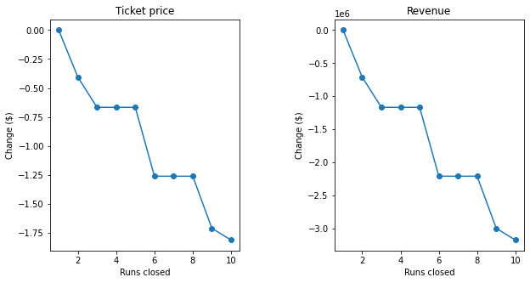

The model suggests that a reduction of one run will not impact ticket and revenue; however, further shutdowns of more runs will negatively impact the resort’s revenue.

**Scenario II.** The model predicted that an additional run with an increase of 150 feet to the vertical drop, and an additional chair lift will increase the ticket price by $2. This price increase reflects a total revenue of $3,474,538. This revenue more than doubles the amount spent on the additional chair lift.

**Scenario III.** In combination with *Scenario II***,** an addition of 2 acres of snow maker area coverage leads to the same outcome as *Scenario II.*The ticket prices will be increased by $2 and the revenue will be roughly #3.5M.

**Scenario IV.** The model predicted that an increase of 0.2 miles to the longest run in the resort and a 4-acre increase to the snow maker area coverage will make no difference to the current ticket price. Therefore, this option will not make any more revenue than what the resort currently makes.

As determined by the model, the second and third scenarios seem to be a great option in terms of maximizing the resort’s revenue. Depending on the cost of adding an additional snow maker coverage to the resort, the author would either go with *Scenario 2* or *Scenario 3.* It doesn’t look like reducing the amenities provided currently in the resort will put the company’s revenue on the positive.

**Limitations**

There are limitations to this project. The data used to develop the model assumes accuracy from the resorts across the country. It also does not provide valuable data that could further inform our model and decision-making. This includes but not limited to resort expenses, number of customers per day, visitor frequency throughout the day, etc.

The most important factor amongst this missing information is the resort expenses. Obtaining knowledge on how much building new amenities and maintaining them is essential in determining the necessary ways at which we can maximize the income of the company while making sure that operational costs are low.

**Appendix**

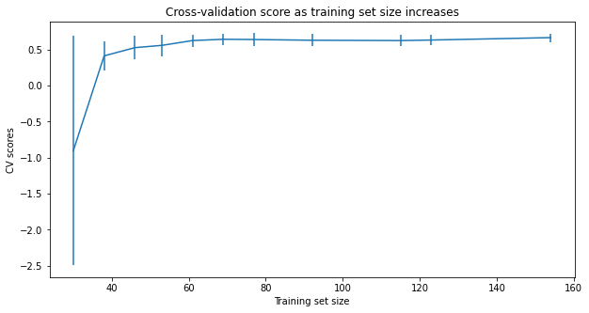

**Figure 1.** Cross0validation score for the random forest model

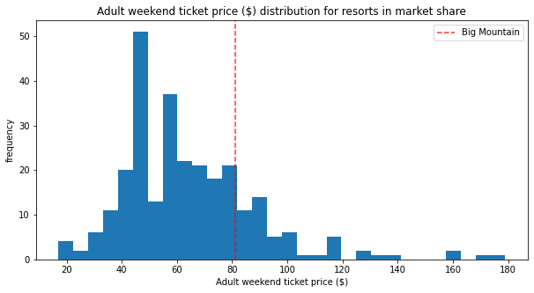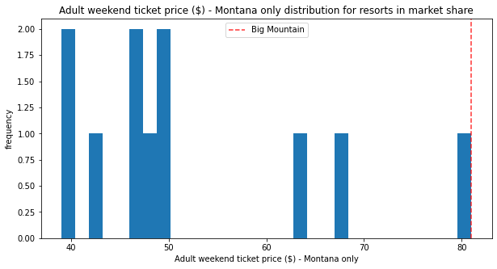

**Figure 2.** Ticket prices distribution for 1. Across all states (top) and 2. In Montana (bottom).

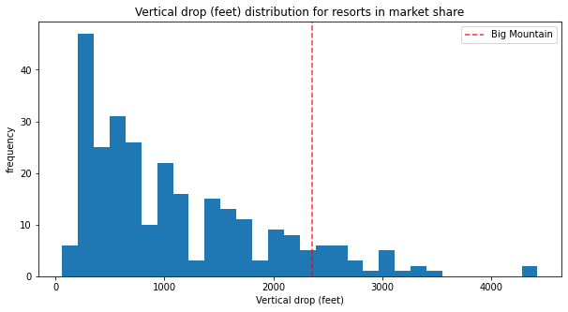

**Figure 3.** Vertical drop (feet) distribution across all resorts in the market.

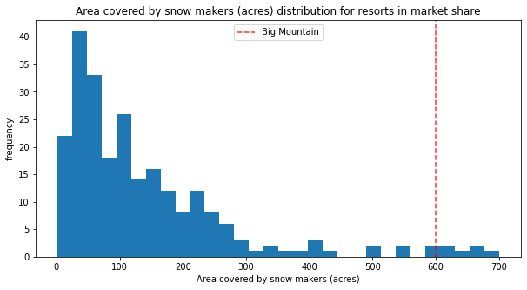

**Figure 4.** Area covered by snow makers (acres) distribution across all resorts in the market.

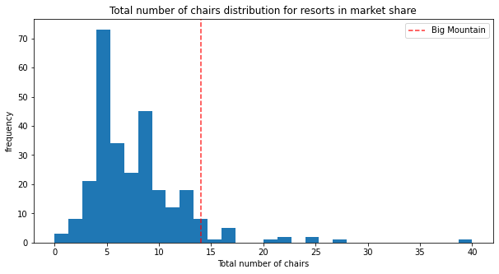

**Figure 5.** Total number of chairs distribution across all resorts in the market.

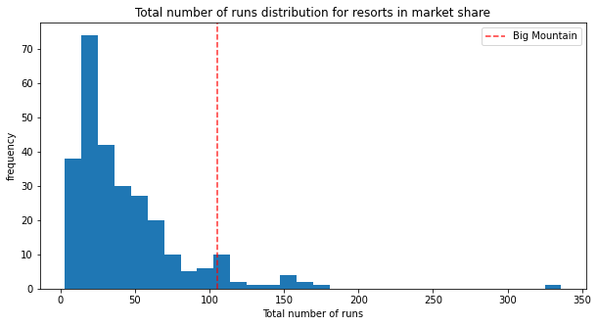

**Figure 6.** Total number of runs distribution across all resorts in the market.